# MongoDb day 1 task

Product JSON:<https://github.com/rvsp/database/blob/master/mongodb/product.json>

1. Find all the information about each products : db.users.users.find().toArray()

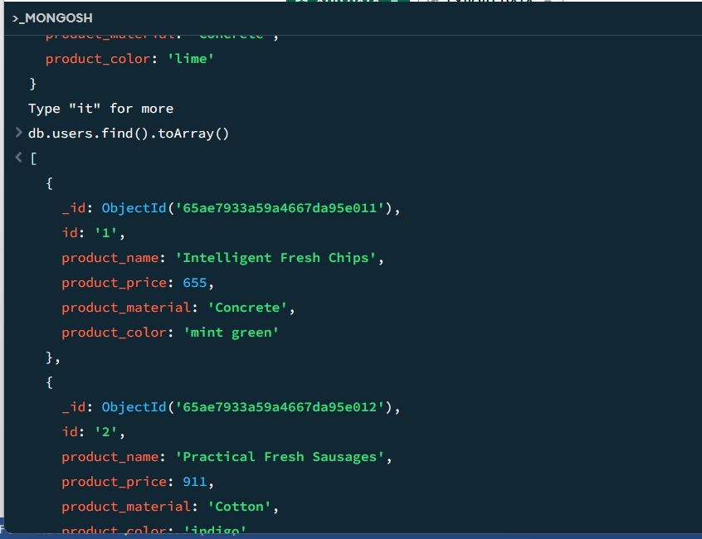

[

{

_id: ObjectId('65ae7933a59a4667da95e011'),

id: '1',

product_name: 'Intelligent Fresh Chips',

product_price: 655,

product_material: 'Concrete',

product_color: 'mint green'

},

{

_id: ObjectId('65ae7933a59a4667da95e012'),

id: '2',

product_name: 'Practical Fresh Sausages',

product_price: 911,

product_material: 'Cotton',

product_color: 'indigo'

},

{

_id: ObjectId('65ae7933a59a4667da95e013'),

id: '3',

product_name: 'Refined Steel Car',

product_price: 690,

product_material: 'Rubber',

product_color: 'gold'

},

{

_id: ObjectId('65ae7933a59a4667da95e014'),

id: '4',

product_name: 'Gorgeous Plastic Pants',

product_price: 492,

product_material: 'Soft',

product_color: 'plum'

},

{

_id: ObjectId('65ae7933a59a4667da95e015'),

id: '5',

product_name: 'Sleek Cotton Chair',

product_price: 33,

product_material: 'Fresh',

product_color: 'black'

},

{

_id: ObjectId('65ae7933a59a4667da95e016'),

id: '6',

product_name: 'Awesome Wooden Towels',

product_price: 474,

product_material: 'Plastic',

product_color: 'orange'

},

{

_id: ObjectId('65ae7933a59a4667da95e017'),

id: '7',

product_name: 'Practical Soft Shoes',

product_price: 500,

product_material: 'Rubber',

product_color: 'pink'

},

{

_id: ObjectId('65ae7933a59a4667da95e018'),

id: '8',

product_name: 'Incredible Steel Hat',

product_price: 78,

product_material: 'Rubber',

product_color: 'violet'

},

{

_id: ObjectId('65ae7933a59a4667da95e019'),

id: '9',

product_name: 'Awesome Wooden Ball',

product_price: 28,

product_material: 'Soft',

product_color: 'azure'

},

{

_id: ObjectId('65ae7933a59a4667da95e01a'),

id: '10',

product_name: 'Generic Wooden Pizza',

product_price: 84,

product_material: 'Frozen',

product_color: 'indigo'

},

{

_id: ObjectId('65ae7933a59a4667da95e01b'),

id: '11',

product_name: 'Unbranded Wooden Cheese',

product_price: 26,

product_material: 'Soft',

product_color: 'black'

},

{

_id: ObjectId('65ae7933a59a4667da95e01c'),

id: '12',

product_name: 'Unbranded Plastic Salad',

product_price: 89,

product_material: 'Wooden',

product_color: 'pink'

},

{

_id: ObjectId('65ae7933a59a4667da95e01d'),

id: '13',

product_name: 'Gorgeous Cotton Keyboard',

product_price: 37,

product_material: 'Concrete',

product_color: 'sky blue'

},

{

_id: ObjectId('65ae7933a59a4667da95e01e'),

id: '14',

product_name: 'Incredible Steel Shirt',

product_price: 54,

product_material: 'Metal',

product_color: 'white'

},

{

_id: ObjectId('65ae7933a59a4667da95e01f'),

id: '15',

product_name: 'Ergonomic Cotton Hat',

product_price: 43,

product_material: 'Rubber',

product_color: 'mint green'

},

{

_id: ObjectId('65ae7933a59a4667da95e020'),

id: '16',

product_name: 'Small Soft Chair',

product_price: 47,

product_material: 'Cotton',

product_color: 'teal'

},

{

_id: ObjectId('65ae7933a59a4667da95e021'),

id: '17',

product_name: 'Incredible Metal Car',

product_price: 36,

product_material: 'Fresh',

product_color: 'indigo'

},

{

_id: ObjectId('65ae7933a59a4667da95e022'),

id: '18',

product_name: 'Licensed Plastic Bacon',

product_price: 88,

product_material: 'Steel',

product_color: 'yellow'

},

{

_id: ObjectId('65ae7933a59a4667da95e023'),

id: '19',

product_name: 'Intelligent Cotton Chips',

product_price: 46,

product_material: 'Soft',

product_color: 'azure'

},

{

_id: ObjectId('65ae7933a59a4667da95e024'),

id: '20',

product_name: 'Handcrafted Wooden Bacon',

product_price: 36,

product_material: 'Concrete',

product_color: 'lime'

},

{

_id: ObjectId('65ae7933a59a4667da95e025'),

id: '21',

product_name: 'Unbranded Granite Chicken',

product_price: 90,

product_material: 'Metal',

product_color: 'gold'

},

{

_id: ObjectId('65ae7933a59a4667da95e026'),

id: '22',

product_name: 'Ergonomic Soft Hat',

product_price: 99,

product_material: 'Rubber',

product_color: 'black'

},

{

_id: ObjectId('65ae7933a59a4667da95e027'),

id: '23',

product_name: 'Intelligent Steel Pizza',

product_price: 95,

product_material: 'Cotton',

product_color: 'azure'

},

{

_id: ObjectId('65ae7933a59a4667da95e028'),

id: '24',

product_name: 'Tasty Rubber Cheese',

product_price: 47,

product_material: 'Frozen',

product_color: 'orchid'

},

{

_id: ObjectId('65ae7933a59a4667da95e029'),

id: '25',

product_name: 'Licensed Steel Car',

product_price: 20,

product_material: 'Cotton',

product_color: 'indigo'

}

]

2. Find the product price which are between 400 to 800

Answer: db.users.find({$and:{[{product_price:{$gt:400}},{product_price:{$lt:800}}]})

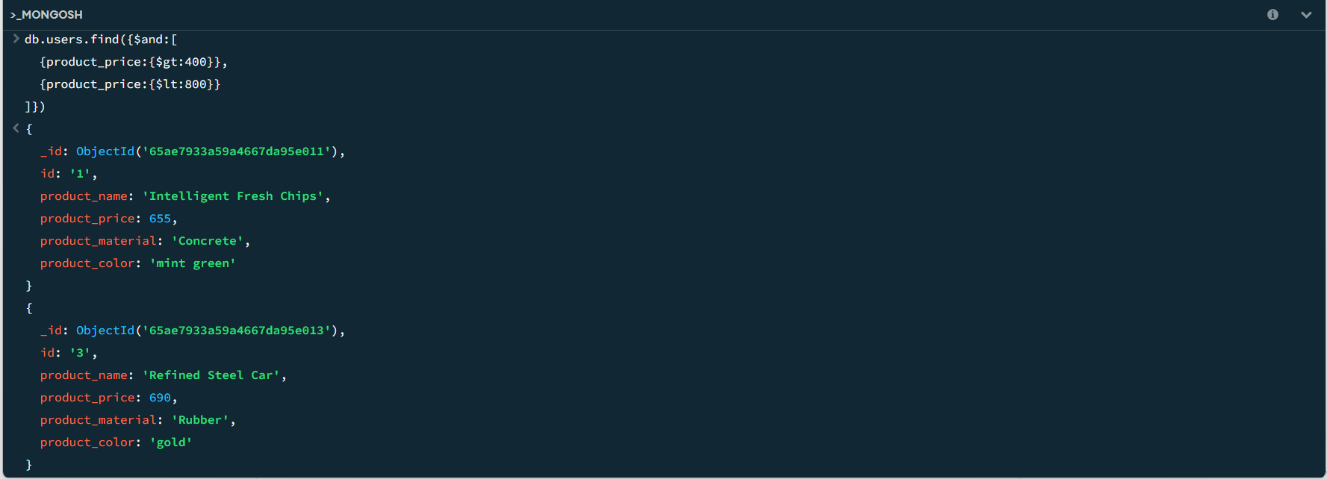

3. Find the product price which are not between 400 to 600

Answer: db.users.find({product}_price: {$not: {$gt:400,$lt:800}})

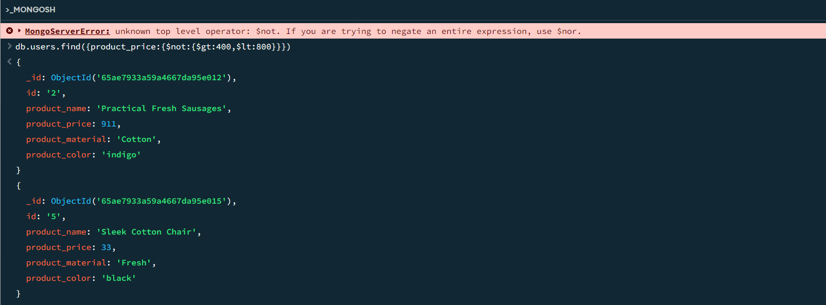

4. List the four product which are grater than 500 in price

Answer: db.users.find({product_price:{$gt:500}}).limit(4)

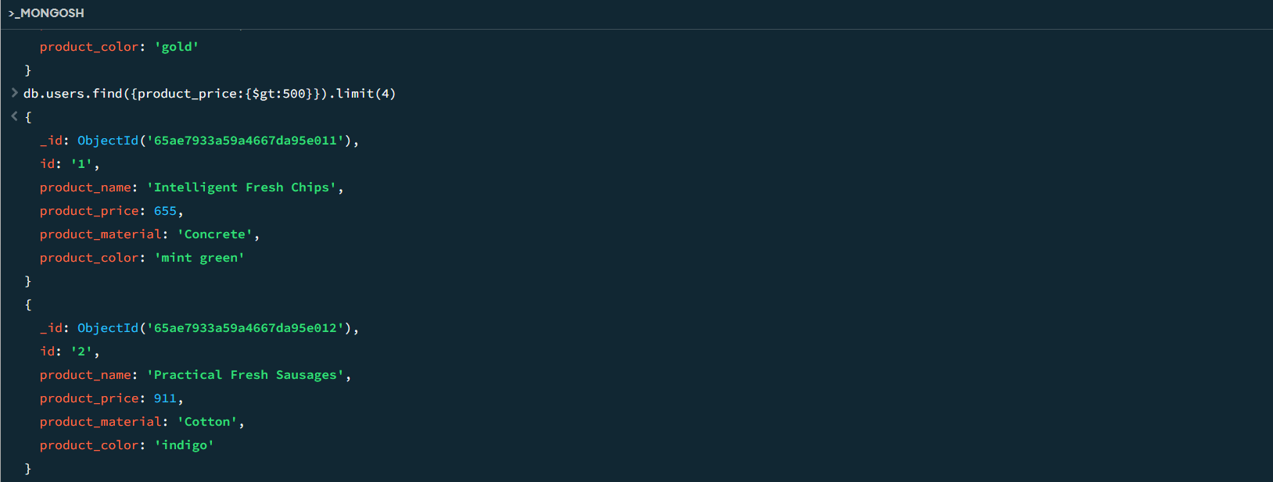

5. Find the product name and product material of each products

Answer: db.users.find({},{‘product_name’:1,’product_material’:1,’_id’:0’}

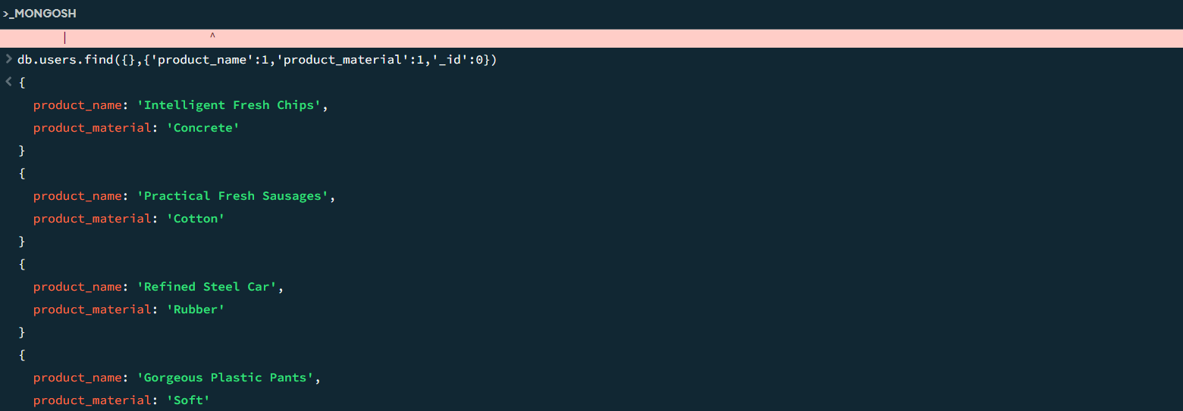

6.Find the product with a row id of 10

Answer: db.users.findOne({id:’10’})

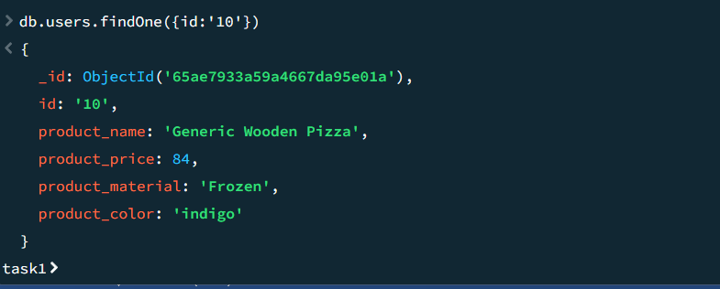

7: Find only the product name and product material

Answer: db.users.find({},{product_name:1,product_material:1,_id:0})

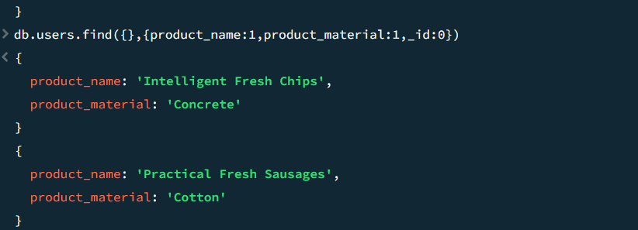

8. Find products which contain product color indigo and product price 492.00

Answer: db.users.find({},{product_color:’indigo’,product_price:492})

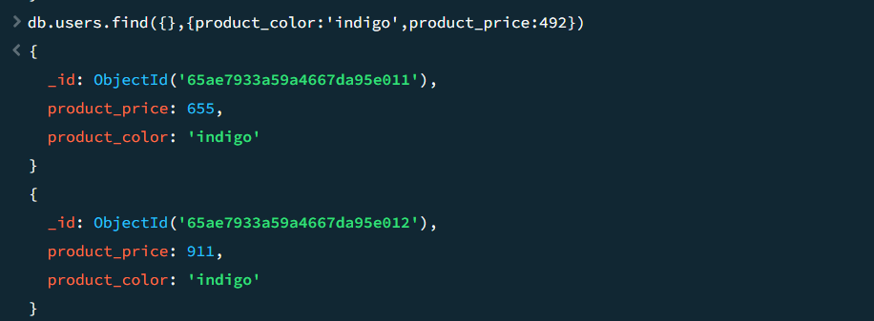

9. Find all products which contain the value of soft in product material

Answer: db.users.find({product_material:{$regex:/soft/i}})

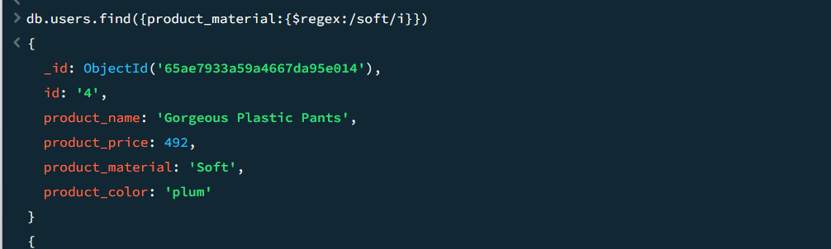

10. Delete the products which product price value are same

Answer: db.products.aggregate([{$group:{_id:'$product_price',count:{$sum:1}}}, {$match: {count : {$gt: 1}}}]).forEach((e) => {db.products.deleteMany({product_price: e._id})})